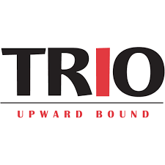

**OLD DOMINION UNIVERSITY**

**CENTER FOR HIGH IMPACT PRACTICES**

Student Success Center, Rm. 2004 – Norfolk, VA 23529

TEL: (757) 683-4315 Fax: (757) 683-3201

https://www.odu.edu/partnerships/community/programs/upwardbound

The Federal TRIO Upward Bound Program at Old Dominion University is accepting applications. Upward Bound is a program for first-generation, low-income students who reside in one of the target area high schools in Norfolk, VA. The goal of Upward Bound is to assist students in graduating from high school and enter postsecondary by providing academic support, tutoring, 1-on-1 counseling, workshops that focus on college prep, financial literacy, SAT and ACT readiness, cultural enrichment, college tours and so much more. As an added bonus, all active participants can be awarded up to $80 a month and are presently provided a monthly gift card for meals, with access to FREE school supplies.

The prospective candidates must meet the income eligibility criteria established by Federal guidelines, be a citizen or national of the United States, must be least 13 years old, be a potential first generation college bound student, and show a need for academic support in order to pursue a degree after high school. Enrolled participants will also be given the opportunity to take part in our 6-week simulated college experience where students simultaneously gain exposure to college life and get a head start on their classes in the fall. For more information or to get an application, visit [www.odu.edu](http://www.odu.edu) and type “Upward Bound” in the search bar. You can also call the Upward Bound Office by dialing (757) 683-4315 to learn more about this amazing program today.

Mrs. Lila Love, Program Director